Cancelling Orders in Praxis
If an order is cancelled, the process by team that occurs is as follows:

Sales Manager
- Make a negative entry in the Building Order Sheet to credit the price of the unit by creating a redline stating which serial numbers were cancelled. In the example below, only one of the two units in the run of units was cancelled so the serial number was noted, and half of the total price was credited. If both were cancelled, the total price would be credited.
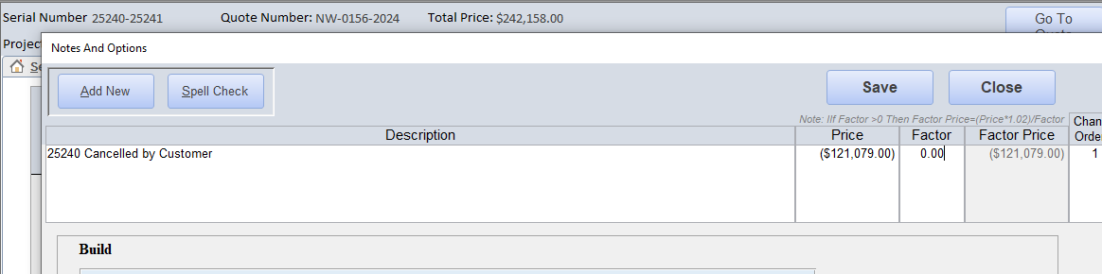
- Attach the Redline Change Order Sheet and email Jay Daniels, Jay Vanvlerah, the factory GM, and the factory PC stating:
  - Serial numbers cancelled,
  - Customer PO # affected,
  - Affect on revenue numbers,
  - Reason for cancellation.
  - Any reason we shouldn’t give a full refund and suggestion on refund amount (design costs, materials ordered, etc.)
- Amend the Redline Change Order according to Jay Vanvlerah and Jay Daniels suggestion.
- Once the Redline Change Order is signed, save the email and signed document in the building folder and files.
- Remove the serial number(s) from the Pipeline Report.
- Alert internal teams through standard Redline Change Order process.

Project Coordinator
- Mark status as “canceled” for that unit in the Project Log.

Project Coordinator & General Manager
- Review reports together to ensure the info provided is correct in the project log.

General Manager
- Submit reports to Devin or manager.

